

Software Requirements Specification

Job Forum Discussion

Version 1.1

Prepared by Team Deep Blue

|  |  |  |
| --- | --- | --- |
| <name> | <student #> | <e-mail> |
| Lauren Scott | 011638112 | lauren.g.scott@wsu.edu |
| Joshua Sweet | 011630924 | joshua.d.sweet@wsu.edu |
| Sravani Ravula | 011629639 | sravani.ravula@wsu.edu |
|  |  |  |

|  |  |
| --- | --- |
|  |  |
| Date: | 7 October 2018 |
|  |  |
|  |  |
|  |  |

Contents

Revisions iii

1 Introduction 1

1.1 Document Purpose 1

1.2 Product Scope 1

1.3 Intended Audience and Document Overview 1

1.4 Definitions, Acronyms and Abbreviations 1

1.5 Document Conventions 2

1.6 References and Acknowledgments 2

2 Overall Description 3

2.1 Product Perspective 3

2.2 Product Functionality 3

2.3 Users and Characteristics 3

2.4 Operating Environment 4

2.5 Design and Implementation Constraints 4

2.6 User Documentation 4

2.7 Assumptions and Dependencies 5

3 Specific Requirements 6

3.1 External Interface Requirements 6

3.2 Functional Requirements 7

3.3 Behaviour Requirements 8

4 Other Non-functional Requirements 9

4.1 Performance Requirements 9

4.2 Safety and Security Requirements 9

4.3 Software Quality Attributes 9

5 Other Requirements 10

Appendix A – Data Dictionary 11

Appendix B - Group Log 12

Revisions

| Version | Primary Author(s) | Description of Version | Date Completed |
| --- | --- | --- | --- |
| 1.0 | Joshua Sweet, Sravani Ravula, and Lauren Scott | Initial completion of the main componets of the document. | 10/04/18 |
| 1.1 | Joshua Sweet, Sravani Ravula, and Lauren Scott | Diagrams were added to the document to make full completion. | 10/05/18 |

# 

# Introduction

The purpose of this project is to provide a forum discussion service where users can sign up for an account, post discussions related to jobs, and view and respond to other users‘ posts. This section will provide an overview of this document and the product it is about.

## Document Purpose

This document specifies the software requirements for a job-related discussion board. Users will be able to create an account, view posts, and make their own posts. The project will be able to store user data and posts which were made in a database. The document discusses all parts of the project, which will be self-contained and will be version 1.0 of the product.

## Product Scope

The product will allow users to create an account and post job-related discussions in a forum board. This will be done by having a landing page where each discussion is displayed with its own title, and the user will be able to click the title of a discussion to be taken to a page showing the parent post with all its replies. The users will also be able to insert their own replies if they wish to do so. They will be able to view the discussions without an account, but will not be allowed to post without one. The landing page will contain a section that allows the user to sign in, sign out, or create an account.

This product will benefit users by allowing them to discuss job-related topics with other people. These topics include work-related activites and where to apply for jobs, interviews, or internships. Advice will be easy to access, as users will be able to have discussions from their own homes and, due to the open nature of the forum, will not have to search out specific people to talk to. Discussing work-related acitivies could also allow people to give updates to other users of how they are managing their lives with the jobs they have, providing an understanding of what the work environment might be like.

## Intended Audience and Document Overview

This document is meant to be read by clients and the professor. The rest of the document contains specific information about the product, including how it performs and diagrams representing its process flow. It is recommended that clients move on to section 2, Overall Description, to receive an overview of the product and then browse the rest of the document if they would like a more detailed understanding. The professor may wish to check the group log or revisions table to read about the development of the document before continuing to the next sections.

## Definitions, Acronyms and Abbreviations

* FAQ – Frequently Asked Questions
* IEEE – Institute of Electrical and Electronics Engineers
* OS – Operating System
* SLP – Service Learning Project
* TDD – Test-Driven Development

## Document Conventions

<In general this document follows the IEEE formatting requirements. Use Arial font size 11, or 12 throughout the document for text. Use italics for comments. Document text should be single spaced and maintain the 1” margins found in this template. For Section and Subsection titles please follow the template.

TO DO: Describe any standards or typographical conventions that were followed when writing this SRS, such as fonts or highlighting that have special significance. Sometimes, it is useful to divide this section to several sections, e.g., Formatting Conventions, Naming Conventions, etc.>

This document follows IEEE formatting requirements. It is single-spaced and has 1” margins. The font used for a majority of the document is Arial 11 point font.

## References and Acknowledgments

PlantUML.com. (2018). Open-source tool that uses simple textual descriptions to draw UML diagrams.. [online] Available at: <http://plantuml.com/> [Accessed 7 Oct. 2018]

# Overall Description

## Product Perspective

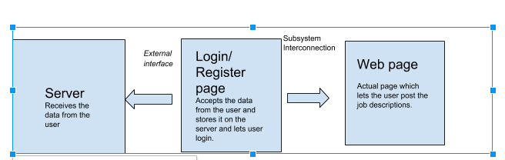This is a new, self-contained product. It will consist of linked web pages through which users can navigate the online forum and the external server, with which the user will never interact directly. The first time a new user registers, their information will be collected on the server, and then when they log in, their username and password will be checked in the database to see if it is correct. After verification, the user will be directed to the landing page where they will be able to view and create posts regarding jobs.

Figure 1 : Context Diagram.

## Product Functionality

* Landing page: The first thing users see when they access the site. From here, they will be able to create an account, log in, or view existing posts.
* Account creation: The user will be able to create an account which will allow them to post on the forum.
* Ability to log in and out: The user can log in by entering their username and password if they have an account.
* Viewing posts/threads: Users will be able to view the list of threads and navigate through other users’ threads.
* Responding to other people’s posts: If logged in, the user will be able to add replies to other users’ threads.
* Creating an original post: If logged in, the user will be able to start their own thread, to which others are able to reply.

## Users and Characteristics

The primary and intended users of this product will be people who are looking for a job or internship. This includes people who are looking for a first job and people who are out of work. It is also possible that people who are looking to hire might also use this product, but the main audience is those looking for work, so that is the most important audience to consider.

## Operating Environment

The environment we are using is subdivided into three parts: the server, the login page, and the web pages where users will actually view and create posts. The server environment is maintained in the form of rows and columns on the online Mysql server where the user’s personal data is stored. This is connected to the login page and the account creation page, and the commuication between them happens through PHP. The login page, account creation page, and discussion page are constructed with HTML and styled with CSS for the appearance of the product.

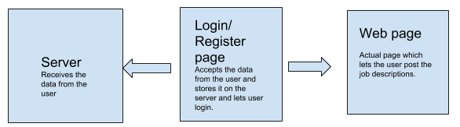

Figure 2: Overall Environment.

## Design and Implementation Constraints

Time available is a possible restraint to the product. For example, features such as being able to view another user’s profile or flag abusive comments are standard for most online message boards, but are not an implementation priority due to the amount of time it will take to construct the rest of the website.

The languages necessary to use when building webpages might also be a restraint on the project. The development team have various levels of proficiency in HTML, CSS, and PHP, but none have a high amount of experience. Due to the need to research during development, progress may be slowed down or some features may be difficult to implement.

## User Documentation

Most users of the Internet today know how to navigate forums and message boards. For those who don’t or for those who have questions or problems, the product should include a help/FAQ page. There should be a link to this page in the header of the website so that it is accessible from every page. The help/FAQ page should describe what to do if there are problems logging in, creating an account, making posts, and et cetera. Ideally, there would be a way on the website to contact the development team via email in case the FAQ does not cover the problem.

## Assumptions and Dependencies

Assumptions:

* Users will actually post about job related activies rather than something off-topic.
* Users will only create one account for the service.
* The product will be able to function for users across every OS.

Dependencies:

* The product will be hosted on Sravani’s server from her SLP at Clark which would need to be active for the product to function.
* An established internet connection would be required to access the service.
* Any browser extension which interacts with CSS and JS could possibly break part of the service.

# Specific Requirements

## External Interface Requirements

### User Interfaces

A number of screens will be available to users, which they will be able to switch through as they navigate the site:

* The landing page, which will be the first page users see. Users will be able to view a list of the posts on the discussion board and will also be able to log in or create an account.
* The login page, accessible from the landing page.
* The account creation page, also accessible from the landing page.
* An individual page for each thread, which will display the original posts and all replies to that post. Because each new thread will have its own page, the number of pages on the site will grow over time as discussions are had by users.

There should be a link that allows the user to return to the landing page on every other page of the site.

When creating a new reply or thread, the user will be taken to a text box which they will be able to type into. The user will be able to confirm or cancel their post from this page. Users should also be able to delete posts they have made.

### Hardware Interfaces

When the user’s data is provided while signing up for the account in order to use the forum, it is stored on an online Godaddy company server. This data is secured and can only be accessed by that particular user or the administrator. The login page is directly linked to this server and stores the data in an organized way (rows and columns), so it can be easily accessed when requested by that particular user and for the admins to keep record of their users.

### Software Interfaces

The external software interface to the main page is the online database server in order to store the personal information of the user which includes their username and password. This server is connected to the login page. If the user is already a member, they will be redirected to the discussion board’s landing page. If not, the login page will redirect to the account creation page, where the user gives all the information mentioned above and this data is passed on to the server and stored.

### Communications Interfaces

The server will use PHP in order to connect to the webpage, which will receive data and store information in the server. MYSQL will be used to edit the tables or data from the user within the server. The data would be maintained securely on the server and can only be accessed by the admin and the user.

The website will be created using HTML for web contain and CSS for style and flow through the website. Communication between the website and subpages will use HTML scripting and mainly be focused by UI and how the user interacts with the discussion forum.

## Functional Requirements

**3.2.1 Landing Page**

The landing page will be the hub for the site, from which users can navigate through all the threads on the message board, as well as log in, log out, or access the account creation page. If logged in, users will also be able to create their own threads to post on the message board.

The landing page will need to be capable of displaying a list of threads on the site, as well as the thread’s subject line and author. Each of these threads needs to be accessible by clicking on them.

The website will need to communicate with the server to retrieve the necessary data for the landing page. It will also need to be able to tell if the user is logged in or not. Users who are not logged in will receive an error message if they attempt to create a thread.

The links to the login/logout page and the account creation page must be clearly visible so as not to confuse users.

**3.2.2 Accounts**

Users will be able to create accounts with an associated username and password. The user will be required to select a username that is not already in use and an error message will be displayed if they attempt to sign up with a duplicate username.

All user account information will be stored in a database which will be checked for a match when users attempt to log in. If users enter credentials that do not come up with a match, indicating that the user account does not exist or an incorrect password has been entered, an error message will be displayed.

**3.2.3 Posts**

Users who are logged in will be able to create new posts on the message board. There will be two types of posts: threads and replies. Threads will be displayed on the landing page of the website and will each be hosted on their own page. Replies are posts that are added in response to an already-existing thread and will be displayed on the page of the thread. New threads will be creatable from the landing page while replies will be creatable from the page of an existing thread.

Each post will be displayed with its content along with the username of the author and the date and time when the post was created.

Users who are logged in should also be able to delete posts they have made. If a reply is deleted, only that post will be affected. If a user deletes a thread they have created, all related replies will also be deleted.

Users should be given the chance to cancel their action when either creating or deleting a post.

## Behaviour Requirements

### Use Case View

* Use Case: User views posts without logging in.
* Use Case: User logs in, views posts, and/or creates/replies to posts.
* Use Case: User creates account, views posts, and/or creates/replies to posts.

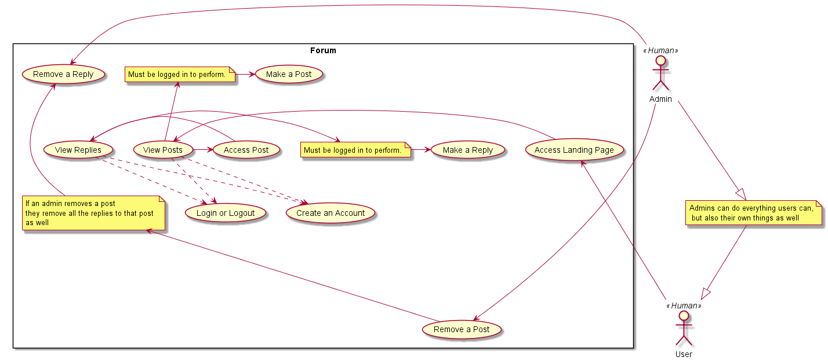

*Figure 3: Use Case Diagram.*

# Other Non-functional Requirements

## Performance Requirements

* Posts and replies should not take more than 5 seconds to show up on the website.
* Internet connection is required. Results may be delayed based on the user’s internet service.
* The webpage, subpages, and online server must be properly connected and responsive to user interaction.

## Safety and Security Requirements

* Abusive posts and replies should not be allowed and would be removed.
* The forum should be used for job-related and educational purposes only.
* The personal data provided by the user can be accessed by the server administrator and that particular user only.

## Software Quality Attributes

**4.3.1 Portability**

The website should be able to run and be loaded on all common operating systems. This can be achieved by using a reuse-oriented development style where the project is developed for one or a few operating systems and is refactored to work for more while maintaining correctness in service outcome if needed.

**4.3.2 Maintainability**

The website should be maintained on the server and should be operating whenever it is not being developed. This will be done by having the project be maintained using Git for version control to keep track of the progress of the development as well as to save the project in case a problem occurs with the server.

**4.3.3 Testability**

The website should be able to be tested in such a way that it meets requirements and also does not encounter any runtime errors. This could be done by using TDD while developing the code for the service.

**4.3.4 Usability**

The webite should be able to be usable by any user, but the preferred users who would use it would be those who actually need it. This would be achieved by testing and making sure the service can work for those across many different OS by creating a use case diagram and making sure the service can fill the requirements of the diagram.

# Other Requirements

This section left intentionally blank.

Appendix A – Data Dictionary

|  |  |  |  |
| --- | --- | --- | --- |
| *Name* | *Type* | *States/IO* | *Description* |
| *Posts* | Functional Requirement | *Input: A variable amount of text*  *Output: A resulting version of the same text users can view.* | *A post contains what users want to say in their post or reply to other users. A requirement for this would be a functioning landing page and that a user is logged in to perform the input.* |
| *Landing Page* | Functional Requirement | *Input: A mouse click to move into a specific post*  *Output: A list of post made by users* | *The main page which displays all of the posts available. A requirement for this would be that the service is working.* |
| *Account* | Functional Requirement | *Input: Account details, including username and password*  *Output: The ability to make posts* | *An account contains details to allow a user to login and post. A requirmenet is a fucntioning login system which takes a password and recognizes it in a database.* |
| *Server Status* | State | *Off or on* | *If the server is on or off, which allows users to use the service. The requirement is not set by us, but by the people who own the server.* |
| *Service Status* | State | *Off or on* | *If the software service is active or not. The requirement would be that the service is not being developed at that time and the server is on.* |
| *UI* | Constant |  | *The UI should look the same for all screen sizes. The requirment would be software code to force this.* |

Appendix B - Group Log

10/4/18 13:30-14:25: Initial setup for the construction of this document, sharing github link for the project, and discussing ways the service would be made.

10/5/18 10:45-14:30 : More develop on this document, sharing more contact information and finished up the content part of the project.